Assessment idea

**Elevator pitch**

This project will demonstrate how different behaviors interact in a maze, with a townsperson trying to make their way through the maze whilst a knight is going to be wandering around randomly until it is in rang the it will follow the townsperson.

**Movement**

Using an A* library.

I’m going to be utilizing a grid based system to assign values to the walls and paths of my maze to allow the program to see where they are able to move. For example, a one value would tell the agent that they are able to move to a location and a zero would tell it that it couldn’t move to that square.

Map

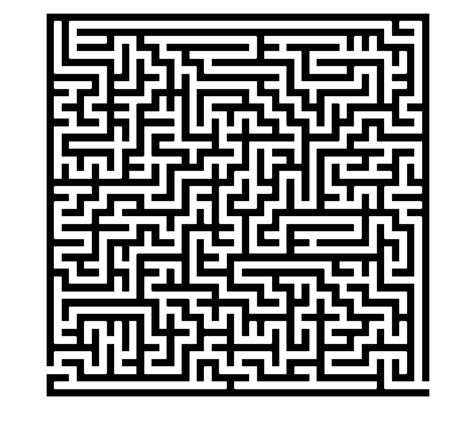

**Agents**

For my project I intend to have two agents in the maze with two separate types of behavior each. The two agents I intend to have will be a trapped townsperson and a knight that is patrolling the maze for intruders.

Townsperson

 

Townsperson - Behaviors

Trying to find a path through a maze.

Behaviors

- Flee

- Follow path

Knight

 

Knight - Behaviors

Trying to find the townsperson.

- Follow

- Wander